I have confirmed that I observed the output "hello world" using the source code

     -- hello.cpp (in C++)

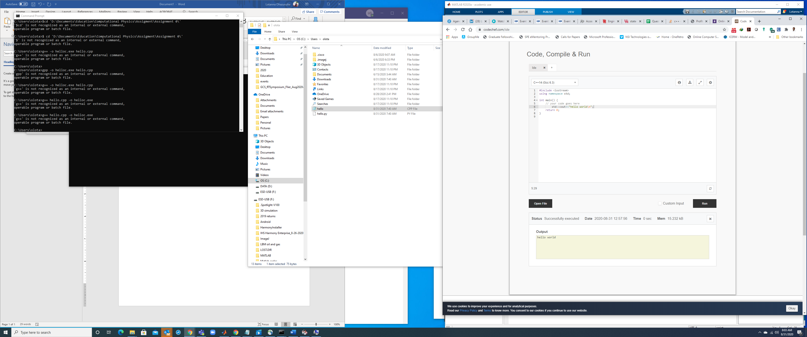

     -- hello.m (in Matlab)

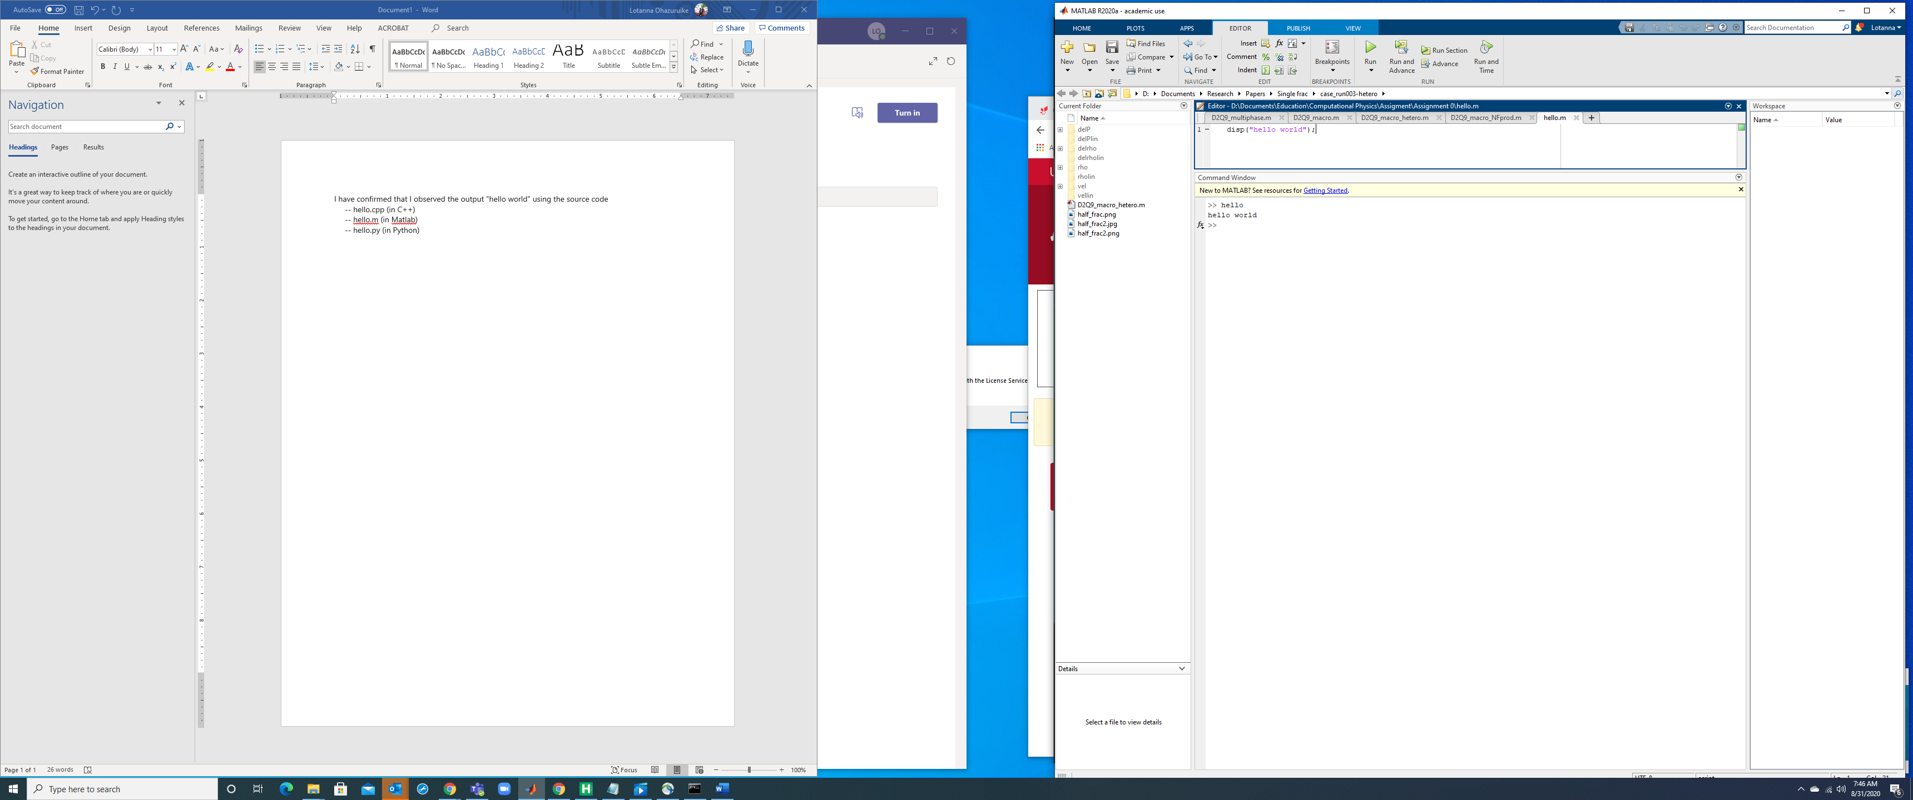

     -- hello.py (in Python)

